BUSINESS GUIDELINES ON THE USE OF FOREIGN GUARANTEES BY NON-RESIDENTS FOR THE COVERAGE OF COMMON TRANSIT MOVEMENTS STARTING IN UKRAINE

The Guidelines include the following steps:
- Registration in the customs authorities of Ukraine and obtaining UA registration number
- Obtaining credentials for the submission of common transit declarations
- Submission of common transit declarations with foreign guarantees

Important note
Guarantees in NCTS have to be geographically valid in at least two contracting parties to the Convention on a common transit procedure (Andorra, Switzerland, EU, United Kingdom, Island, North Macedonia, Norway, Serbia, San Marino, Turkey, Ukraine) (according to the needs and request of the holder of the procedure). For the EU, a guarantee has to be valid in all 27 EU Member States.
Geographical validity of comprehensive or individual guarantee in form of undertaking given by a guarantor according to Article 12 of Appendix I to the Convention on a common transit procedure is defined by indicating in the guarantor’s undertaking an address for service or appointment of an agent in each country of the Contracting Parties involved in the common transit operation.
If a holder of the procedure would like to extend the geographical validity of its guarantee (in particular, comprehensive guarantee) to Ukraine, the holder has to request an update from its guarantor and afterward update the guarantee in its Customs Office of Guarantee.
For Guarantee Waiver a holder of the procedure has to request an update from its Customs Office of Guarantee.
Once a guarantee is updated to include Ukraine in guarantee management module of NCTS of relevant country of the Contracting Parties it can be technically used in Ukraine.
To be able to start common transit movements with a use of foreign guarantee in Ukraine holder of the procedure have to be registered by customs authorities of Ukraine as described below.

І. Registration in the customs authorities of Ukraine and obtaining UA registration number

  - Registration of non-residents in Ukraine is regulated by the provisions of part eight of Article 455 of the Customs Code of Ukraine and the Procedure for registration of persons who, during their activities, participate in relations regulated by the legislation of Ukraine on customs matters, approved by the Order of the Ministry of Finance dated 15.06.2015 No. 552 (as amended) (hereinafter – the Procedure).

  - It is possible to get acquainted with more detailed information on the registration of non-residents on the official website of the State Customs Service of Ukraine (Registration of non-residents) in both Ukrainian and English languages.

  - It is possible to register:
- when entering or leaving Ukraine by filling out the application form directly at the border crossing point (BCP) and providing a copy of the registration certificate of a non-resident issued by the competent authority of the country of registration;
- by sending a completed application form by post to any customs office and providing a copy of the registration certificate issued by the competent authority of the country of registration;
- submit directly to any customs office a completed application form and a copy of the registration certificate issued by the competent authority of the country of registration, or submit these documents through an authorized person acting on the basis of a power of attorney from a non-resident, or through a customs clearance agent acting on the basis of an agreement between a non-resident and a Ukrainian customs broker.

  - The application form can be filled in any language of official international communication. To speed up the processing of information, it is desirable to fill it in Ukrainian or English.

  - The application form (Annex 3 to the Procedure) and an example of filling it in English can be found below.

  - After entering the data from the application into the information system of the customs service, a non-resident person will be assigned a temporary registration number within one hour.

  - Within 5 (five) working days the non-resident is informed about the registration and assignment of the UA registration number via e-mail, specified in part 5 of the application form “Person’s contact details”.

  - UA registration number for non-residents has the following structure:
1 – “UA”, alpha-2 code of Ukraine;
2 – alpha-2 country code, where the non-resident is registered;
3 – 8 digits code, automatically assigned by the system.

  - Register of economic operators can be found on the Single Window web portal.

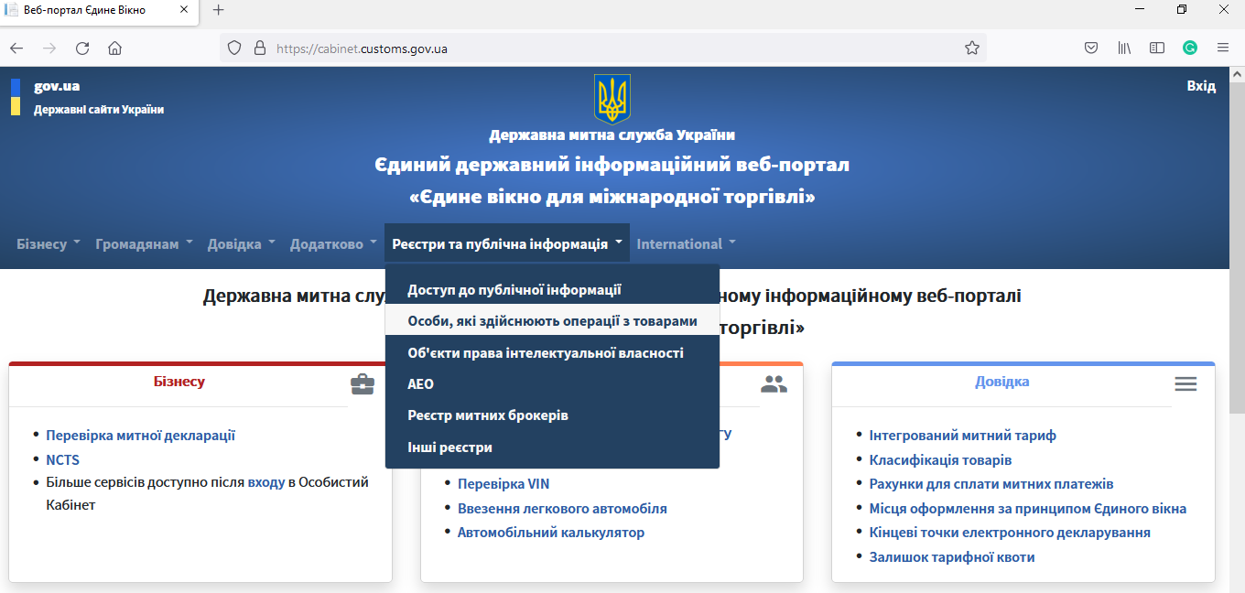
The Single Window web portal of the State Customs Service of Ukraine: navigating to the Register of economic operators

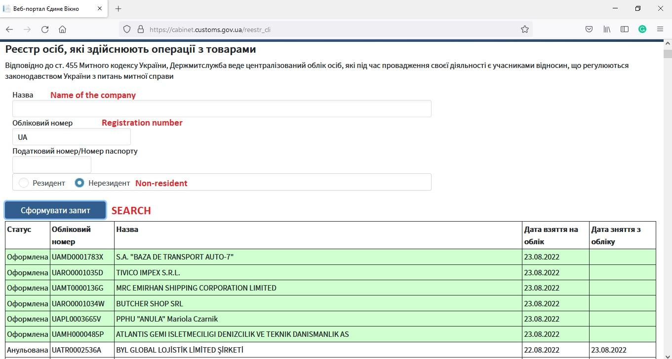
Register of economic operators

II. Obtaining credentials for the submission of common transit declarations

- It is possible to obtain credentials for the UA NCTS application once the non-resident has already obtained a permanent UA registration number (not a temporary one).

- To obtain credentials for the UA NCTS application non-resident has to address a request to the UA NCTS Helpdesk to the e-mail helpdesk_NCTS@customs.gov.ua or via the special web interface https://help.customs.gov.ua/

- The request should contain at least such information:
UA registration number of the company, assigned according to Chapter I of these Guidelines;
Name of the company;
Acceptable login (only Latin letters and numbers are allowed).

- The request should be sent from the business email box of the company and have the title “Registration of non-resident (UA….) for UA NCTS”.

- Within 2 working days in response to the request password (in passworded archive) will be provided back to the company.

- To get the password to the archive the company should call UA NCTS Helpdesk. The up-to-date list of contacts can be found on the tab “Helpdesk” on the official website of the State Customs Service of Ukraine.

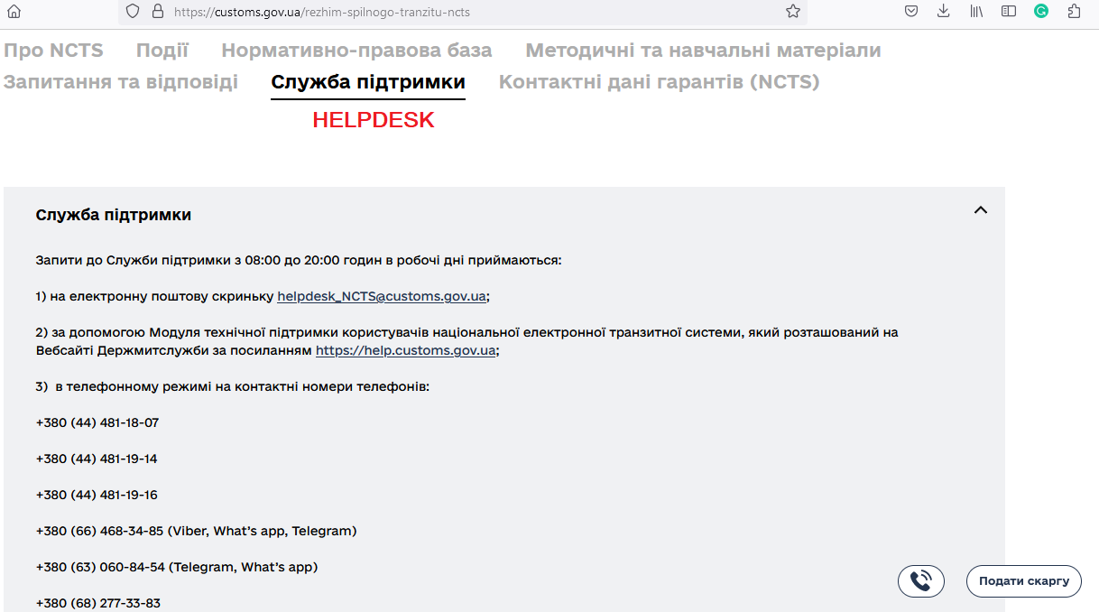
Official website of the State Customs Service of Ukraine:
navigating to the UA NCTS Helpdesk tab

III. Submission of common transit declarations with foreign guarantees

- Submission of common transit declarations by non-residents can be done on its own or via a customs broker.

- If the non-resident decides to submit common transit declarations on its own it may use Trader Portal or another software that supports the submission of such declarations to the UA NCTS application.

- Trader Portal is available by the link https://commontransit.customs.gov.ua/trader/

UA NCTS Trader Portal
- TIN is UA registration number of the company, assigned according to Chapter I of these Guidelines, as login and password should be used credentials received via Helpdesk.

- An interface of Trader Portal is available in both: Ukrainian and English.

- Trader Portal supports the submission of combined T1 and ENS declarations.

- Detailed instructions on filling in common transit declarations can be found on the tab “Methodological and training materials” on the official website of the State Customs Service of Ukraine.

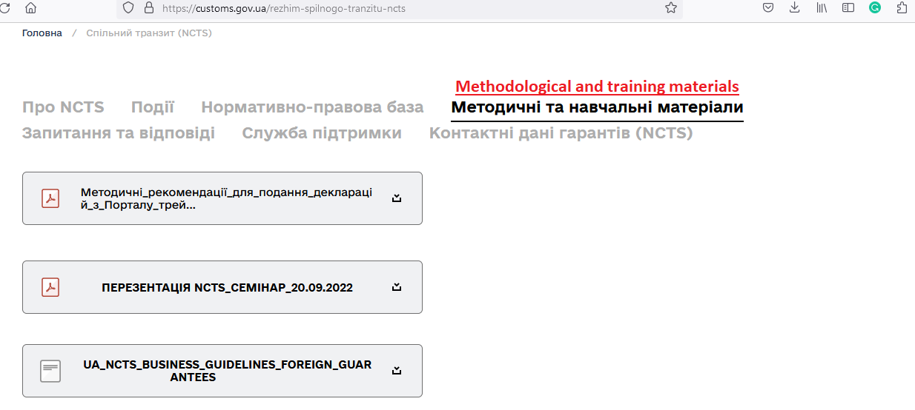
Official website of the State Customs Service of Ukraine:
navigating to the detailed instructions on filling in common transit declarations at the Trader Portal

- If non-resident delegates submission of common transit declarations to a customs broker it may not request credentials for UA NCTS application according to the Chapter II of these Guidelines, as a customs broker, that provides relevant services would use its own credentials for the submission of common transit declarations.

- Register of UA customs brokers is available on the Single Window web portal.

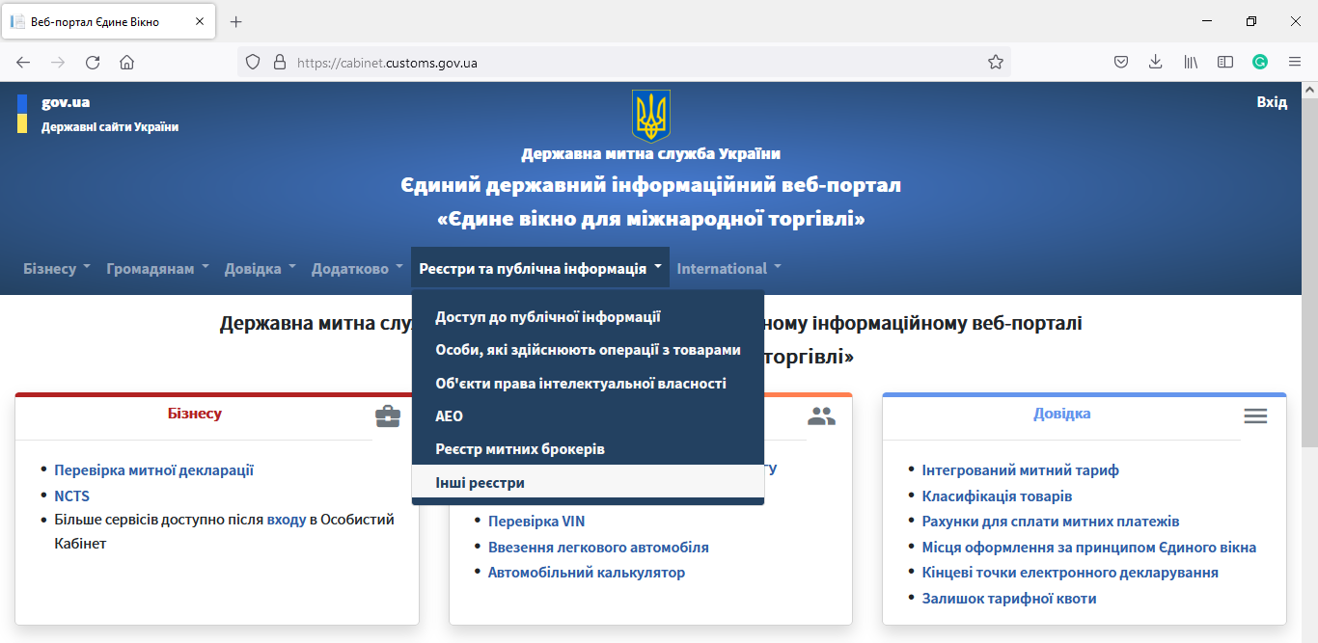
The Single Window web portal of the State Customs Service of Ukraine: navigating to the Register of customs brokers (Excel)

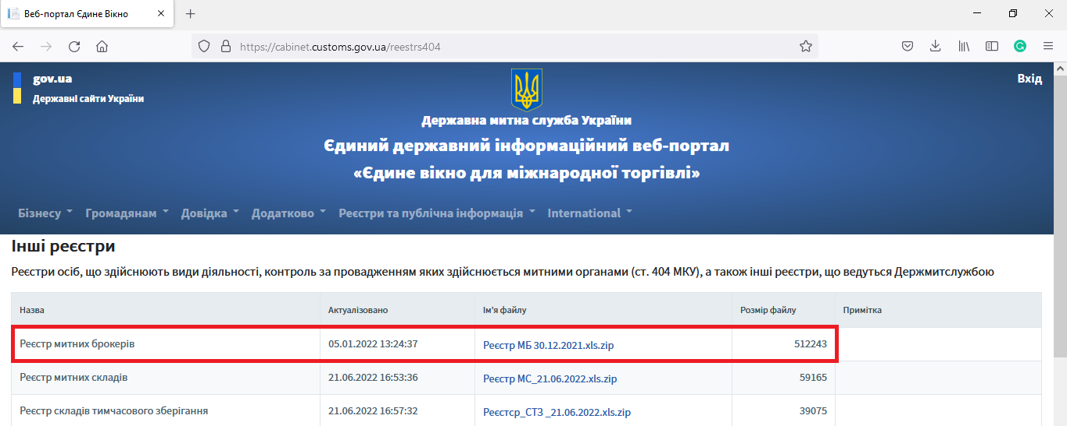
Register of customs brokers available for download as an Excel file

Based on the information from the Excel file, a company can find further information on customs brokers including contact details.

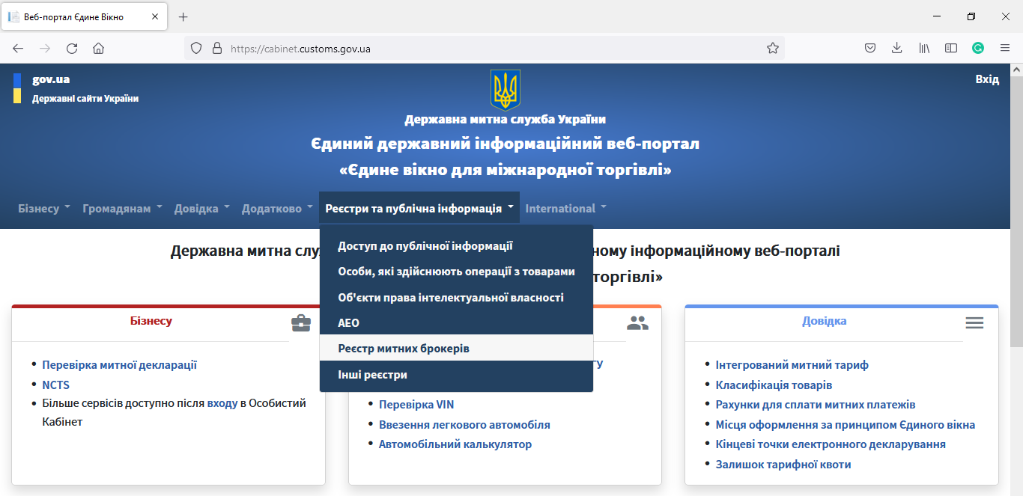
The Single Window web portal of the State Customs Service of Ukraine: navigating to the Register of customs brokers (details)

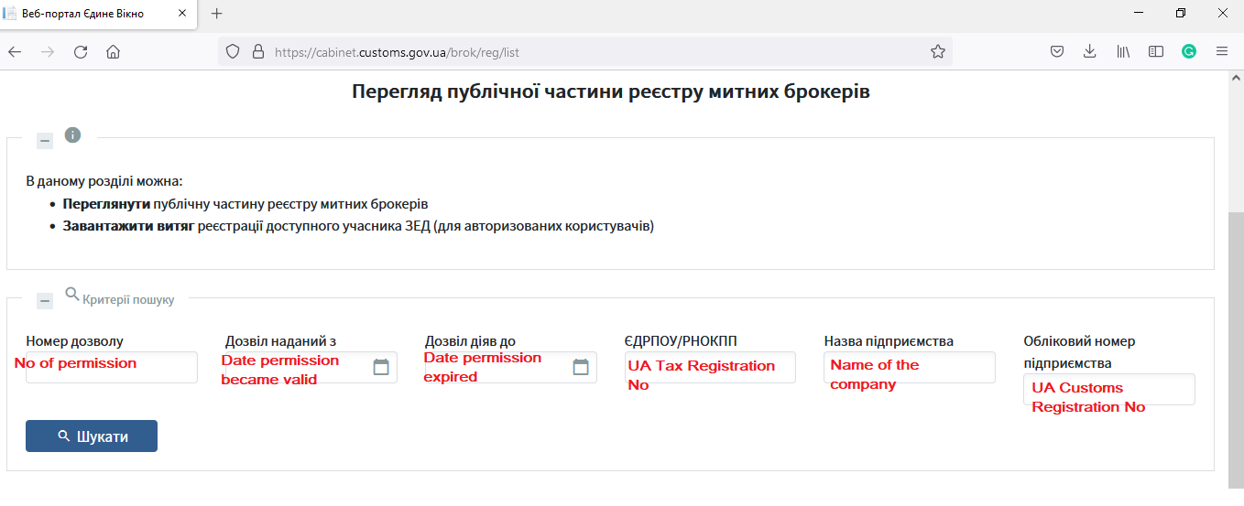
Register of customs brokers (details)

- When filling in the declaration, where a foreign guarantee will be used for the coverage of common transit movement, apart from relevant GRN and access code, it is important to put the TIN of the holder of the procedure as it is in the foreign guarantee and as it was provided to customs authorities of Ukraine in the application form during registration of the non-resident according to the Chapter I of these Guidelines.

____________________________________

End of the document

Please put here UA registration number of the company, assigned according to the Chapter I of these Guidelines

